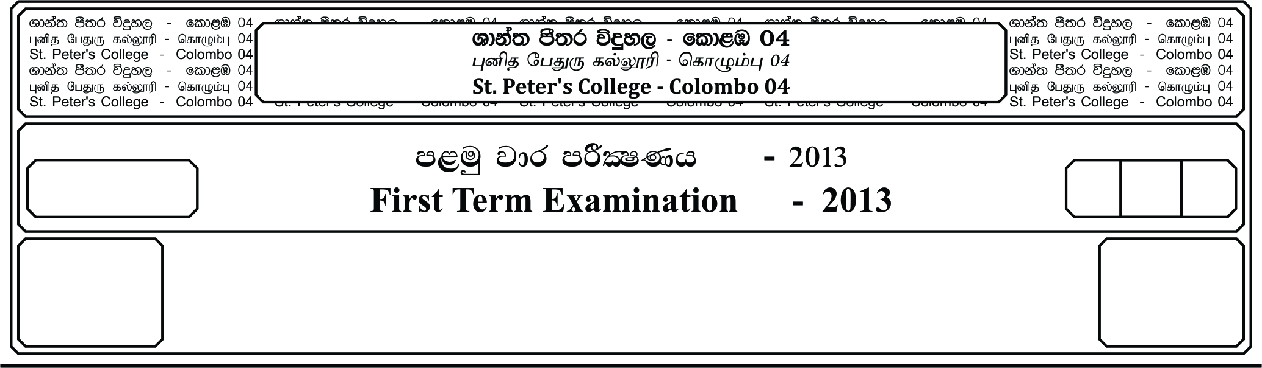

l%sia;shdks O¾uh »

**Christianity I**

**f;jk jdr mßlaIKh - 2020**

**Third Term Examination - 2020**

E

13 fY%aKsh

GRADE 13

II

meh 03

03 Hours

**Answer 5 questions, selecting two questions Part I and there questions from part II.**

01. i. Write the name of the Greek and Latin copy of the Bible. **(02 Marks)**

ii. Write 04 reason for writing the Gospels in Divine inspiration. **(04 Marks)**

iii. Name 04 cities that were situated around the sea of Galilee. **(06 Marks)**

iv. Name 03 main civilizations in the Fertile Crescent. **(10 Marks)**

02. i. Name the two promises of Jacob, the night when he was running to Bethel.

**(10 Marks)**

ii. Name the 04 parable of St. Mathew, which speaks about the kingdom of God.

**(04 Marks)**

iii. Name any 06 Apostles, Jesus chose to carry out his mission. **(06 Marks)**

iv. St. Paul sacrificed his life to spread the kingdom of God among the gentiles and the Jew, likewise how do you take the same to make known Jesus to the whole world.

**(10 Marks)**

03. i. According to the letter to the Corinthians, St. Paul brings about the qualities of love. Name the features of love. **(11 Marks)**

ii. Name 04 miracles Jesus performed **(11 Marks)**

**Part II**

04. i. According to the 1st letter of St. Paul, how would you work in your society, explain it

in minimum of 200 words. **(20 Marks)**

05. i. Name the last 04 kings of Judea, highlight their approach in both the ways, (success and

failures.) **(10 Marks)**

ii. Though Moses refused to accept the vocation given by God, yet God encouraged him

to accept it. **(10 Marks)**

06. i. Name 02 missionary groups arrives in Sri Lanka during the British Era.

**(10 Marks)**

ii. Explain in 05 sentences the way you would act in the society as a youth. Following the

exemplary life of St. Joseph Vaz. **(10 Marks)**

07. i. Explain about Rev. Fr. Jacome Gonsalves who is considered to be the father of Sri

Lankan Literature of Catholicism. Explain in 200 words his contribution to the country.

**(20 Marks)**

08. i. Write the 1st Apostolic journey of St. Paul. **(20 Marks)**